Lab Report
Institutional Affiliation
Date
Lab Week 1
Name: Fill in your name here
We are going to start by exploring some careers of ocean researchers and some basic ocean facts.
You will do to two different locations on a NOAA website, pick categories, and play the multimedia files and read the indicated text. Then answer the questions thoroughly, add your answers to the document and highlight or change the text color so it is easy to see. Log back into blackboard and got to the lab section. Pick on the Turn in Lab 1 and upload the text document by Sept 9th, 2020.
Goto the Ocean Careers page
https://oceanexplorer.noaa.gov/edu/oceanage/welcome.html
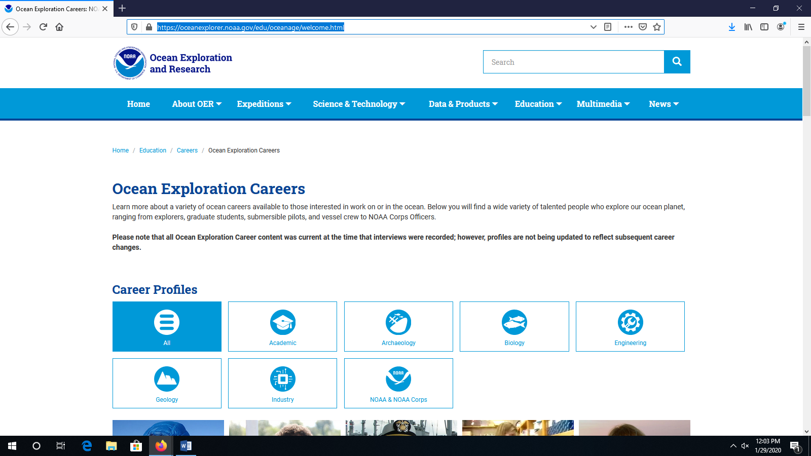

Look at the pictures of the researchers and pick three that interest you (you can also pick the career categories to see which researchers to what short of jobs).
Watch the interview of each researcher and read their biographical information. Answer these questions for each researcher (9 answers total):
- Why did this person get started in ocean exploration?
It was out of admiration from a professional
- Why do you think they are featured on this website?
Their passion and accomplishment in marine exploration.
- What parts of their research can you imagine yourself doing?
My interest is history. Marine archeology perfectly blends with this interest.
Goto the Explorer’s in training page.
https://oceanexplorer.noaa.gov/edu/explorer-in-training/welcome.html
Pick 3 of the students from the page and read there interviews, then answer the following questions for each student (9 answers total):
- Where is this student going to school?
Institute of Marine Science
- Why did they want to do ocean research?
The study was motivated by passion.
- What skills / classes would you need to learn to do this type of research?
- Geography
- Mathematics
- Physics
Goto the Ocean Facts page
https://oceanexplorer.noaa.gov/facts/facts.html
Pick Geology, Archaeology, Multibeam bathometry, plus two other categories to gather facts from (Total of 5):
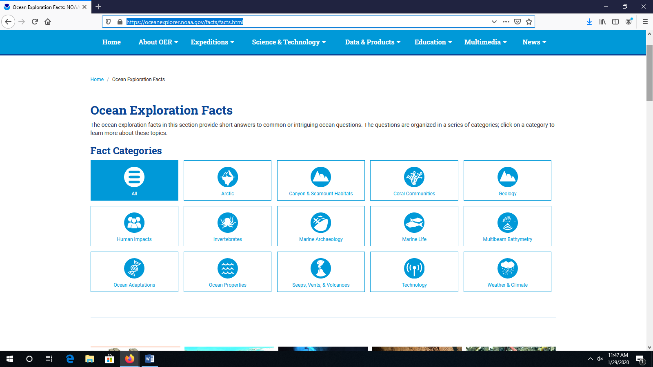
Answer these questions from the 3 listed categories and the two others you choose (10 total answers)–
- Geology – How big is the ocean (area and volume)?
360 million square kilometers
- Geology – What is the best known hotspot?
Hawaii is the best known geology hotspot
- Geology – How does the ocean control the temperature of the air?
The constant evaporation of ocean water increases the humidity and temperature of the surrounding humidity and temperature forming storms and rain which are later carried by trade winds. Therefore, the currents regulate the climate through by counteracting the uneven solar distribution on the surface of the earth.
- Multibeam Bathometry – What is bathometry data collected?
Bathymetry refers to the sea floor close examination and mapping. It entails measuring the ocean depth, and establishing the topography of the ocean floor. The data obtained from bathometry has a wide range of uses such as ocean navigation, charting and fisheries management.
- Multibeam Bathometry – How were ocean depth measurement collected in 1854?
The ocean floor was recorded through the use of Brookes Sounder which was invented then.
Brooke's sounder was invented in 1854. It consisted of a heavy lead weight or shot with a hollow core where the metal rod would be inserted. The vibrations of the rod would help to estimate the ocean depth.
- Multibeam Bathometry – How are temperatures collected in a column of water?
The first step is to establish the location of interest where the float rests. As it moves through the water column, special sensors on board record the temperature, pressure, and salinity, which refers to the concentration of salt in the water.
- Marine Archaeology – Other than shipwrecks, what types of sites interest marine archaeologists?
Other areas of interest in marine archeology include volcanic sites and prehistoric constructions such as graves.
- Marine Archaeology – Make up a question base on the USS Monitor.
What was the initial purpose of the USS Monitor?
- Make up a short answer question from one of the other categories.
The USS Monitor was used during the American Civil War by the federal navy for emergency services. It was designed by John Ericsson. It assisted to blockade the sea supply of the Confederate States.
- How is the information presented in one of the other categories directly related to your daily life?
In marine archeology, excavation of graves and shelter has helped me understand prehistoric history that wouldn't have uncovered.

